
St. Michael & All Angels Episcopal Church

The Fifteenth Sunday after Pentecost
September 06, 2026, 10:00 a.m.
Rite Two

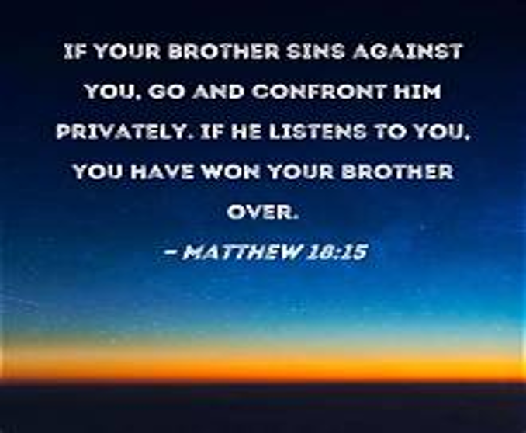

HOLY Eucharist

Instrument Prelude Mrs. Ivana Kenny Carmola
Opening prayer
Almighty and everlasting God, ruler of all things in heaven and earth, hear our prayers for this parish family. Strengthen the faithful, arouse the careless, and restore the penitent. Grant us all things necessary for our common life, and bring us all to be of one heart and mind within your holy Church; through Jesus Christ our Lord. Amen.
Processional Hymn A569, Revive Us Again Revive us Again
THE WORD OF GOD
Opening Acclamation BCP pg. 355
Gloria 356
The Collect of the day Insert
Congregation is seated
The Lessons Exodus 12:1-14
Psalm 149
Glory to the Father, and to the Son, and to the Holy Spirit:
as it was in the beginning, is now, and will be forever. Amen.
Romans 13:8-14
The Gradual Hymn A524, vs 1-2, There Is a Balm in Gilead Balm in Gilead
The Holy Gospel Matthew 18:15-20
The Sequence Hymn A524, vs 3, There Is a Balm in Gilead Balm in Gilead
The Sermon Fr. Jim May
The Nicene Creed Pg. 358
The Prayers of the People, Form 6 392
Confession of Sin & Absolution 360
The Peace A166, In His Presence Tunney

-1-

Please be seated for the Offertory.
Offertory A389, What shall I render douroux
Doxology & Procession A650, Praise God, from Whom All Blessings Flow Hatton
Presentation of the Offering – prayer to be said:
Father, we offer you these gifts which you have given us: this bread, this wine, this money. With them we offer ourselves, our lives, and our work, to become through your Holy Spirit, a reasonable, holy and lively sacrifice. As this bread and wine become the Body and Blood of Christ, so may we and all your people become channels of your love; through the same Christ our Lord. Amen.
Presentation Hymn A529, We Bring the Sacrifice of Praise Dearman
The Holy Communion
The Great Thanksgiving BCP pg. 361-366
Eucharistic Prayer A
Sanctus 362
The Lord’s Prayer 364
The Breaking of the Bread
Agnus Dei
The Invitation
Communion Hymn A686, Let Us break Bread Together Break Bread Together
Meditation Hymn A442, Sweet Hour of Prayer Sweet Hour
Post Communion Prayer BCP. pg. 366
Benediction
Announcements
Recessional Hymn A397, Nothing Between Nothing Between
Dismissal
POSTLUDE

A= African American Heritage Hymnal (ivory))

-2-

PRAYER REQUESTS FOR PEACE AND HEALING
For those at Home
Rosalyn Greene, Ella Woodbury, James Manning, Toni Jarmon, Rev. Leslie and Renee White, Rev. Ralph Griffith, Leonel Jones, Charles Walton, Joan Jackson Taylor, Christine Seymour, Kove Lawson, Cynthia Holland, Harriet Bowen, Livy Hitchcock, Sheila Gonzales, Kurt Blyden, Ashley Rodgers, Sandra Todman-Hart, Teresa Thomas, Elroy Todman, Christopher Marrow, Sean Gray Debra Wynn, Fitzgerald Murraine and Anisah Sabur.
For those in the care of the Doctor
Dourest & Joann Robinson, John Melville, Lauren Sapp, Delores Brown, Hattie Olivia Scott, Jasmine Hartin, Rudolph & Melva Griffith, Pamelia Harris Williams, Kelcey Scott, Erica Scott, Eric Scott, Renrick & Veronica Alleyne, Jeffery Adams, Ena Mason, Darlene Sheppard, Devonia Sears, Landon Dyre, Brittany Lee, Herma Watson Taylor, Barbara Gruden, Carolyn Allen, Ann Dupree, Scott Allen, Ashley Griffith, Lee Scott, Leslie Warren, Will Baker, Ellie Potter, Lennie Helfand, Victor Laurie, Martha Laurie, Pamela Richards, Al Washington, Jesse Stewart, Catherine Davis, Zachery Smith, Julia Joyner, Anne Powell, Proctor Ford, Johnnie Flowers, Leonard Williams, Ethan Pritchard, Annie DePutron, Fr. I. Ranfurly Brown of Nassau and Joao Paulo Pimheriro de Miranda.
For those who care for the sick
Especially all doctors, nurses, scientists, and our own, Dr. Shaun Laurie, Dr. Nwamaka Onyeozili, Dr. Ross Howard McMillan, Dr. Ciara Robinson, Dr. Alaine Sharpe, Dr. Zollie White III, Zuri A. White, Cheston Williams and Edwina Johnson.
For those in the Military
Linzie Bogan ll, Clark Bogan, Brianne Edwards, Vashti Thompson, Douglas Sampson, Jaelyn Guyton, Scott Haverstraw, Zavon Martin and Carina Richardson.
Suggested daily Readings for the Season of Pentecost: September 7 to September 12.
Mon. Job 32:1-10 Psalm 41, 52 John 10:19-30
Tue. Job 29:1-20 Psalm 45 John 10:31-30
Wed. Job 29:1 Psalm 119:49-72 John 11:1-16
Thurs. Job 29:1; 31:1-23 Psalm 50 John 11:17-29
Fri. Job 29:1; 31-24-40 Psalm 40, 54 John 11:30-44
Sat. Job 38:1-17 Psalm .55 John 11:45-54

-3-
SPECIAL PRAYERS
Birthday Prayer
Watch over thy children, O Lord, as their days increase; bless and guide them wherever they may be. Strengthen them when they stand; comfort them when discouraged or sorrowful; raise them up if they fall; and in their hearts may thy peace, which passeth understanding, abide all the days of their lives; through Jesus Christ our Lord. Amen.
Anniversary Prayer
God our Father, we pray that marriage may be held in honor, that couples may live together faithfully, according to their vows; and that members of every family may bear one another’s burdens and so fulfill the law of Christ; for his name’s sake. Amen.
Prayer for the Hurricane Season
Almighty and everlasting God, Lord of Heaven and Earth: Grant unto us thy suppliant people, protection against hurricanes, earthquakes, and other calamities; that in tranquility of weather we may rejoice in the comfort we desire and may always make right use of thy bountiful goodness through Jesus Christ our Lord. Amen.
Capital Campaign Prayer
Most gracious Lord Jesus Christ and generous source of all abundance, in gratitude we invite you to expand our hearts as we seek to increase and improve this place of worship, peace, healing, forgiveness, outreach, service and fellowship. May all who enter here be restored and strengthened on their journey of faith. Guide us Heavenly Father, that we may make manifest your vision of a beloved and enlightened church and community, and be a shining example of the living presence of the Holy Spirit. May we and our Capital Campaign be a channel of God’s abundant grace; through Jesus Christ our Lord we pray. Amen.
HAPPY BIRTHDAY/ANNIVERSARY TO OUR CHURCH FAMILY!
Marie Roberts (9/6), Delores Mitchell (9/7), Eugene Wesley (9/8), Claire Wasson (9/11),
Dr. Neil &. Bridget James (9/6), Fr. Cal & Karen Goodlett (9/9).

Serving today, Sunday, September 6
Crucifer: Mr. James Fort Lectors: Ms. Marie Roberts
Mr. Edward Ornstein
Gospel Book Bearer/MC: Dr. Cyndy Stewart
Mrs. Alexis Roberts McMillan
LEM: Mr. Zollie White, II Organist: Mrs. Ivana Kenny Carmola
Vestry: Ms. Marie Roberts AV: Mr. Christopher White
Altar Guild: Dr. Delores Lawson Ushers & Greeters
Ms. Marie Roberts
-4-

ANNOUNCEMENTS
St. Michael and All Angels Monthly Game Night
Join us on September 9th, from 6:00 p.m. – 9:00 p.m. for an evening of fellowship and fun. Light refreshments (potluck finger foods and drinks) will be provided. Come out and enjoy the time together—bring a friend!
Pray especially for the following:
Carlton Maddox–trying to put his life back together
John Melville–recovering at home
Ann Powell–in the care of the doctor
JoAnn Robinson–recovering at home
Eugene Wesley, III
Skyler Scott

Do This in remembrance of Me

Approaching the Lord’s Table
Come to this sacred table, not because you must, but because you may.

Come to testify not that you are righteous, but that you are righteous, but that you sincerely love our Lord Jesus Christ, and desire to be his true disciple.

Come, not because you are strong , but because you are weak; not because you have any claim on heaven’s rewards but because in your frailty and sin you stand in constant need of heaven’s mercy and help.

Come, not to express an opinion, but to seek his presence and to pray for God’s direction in your life.

-5-

New Priest Search Prayers

Prayer 1: For Our Church Committee

Gracious God,

As we seek the shepherd for our congregation, grant us patience and unity. May we remain faithful in worship, open in fellowship, and steadfast in love, trusting Your wisdom in this transition.

Prepare our hearts to welcome You chosen servant.

Amen.

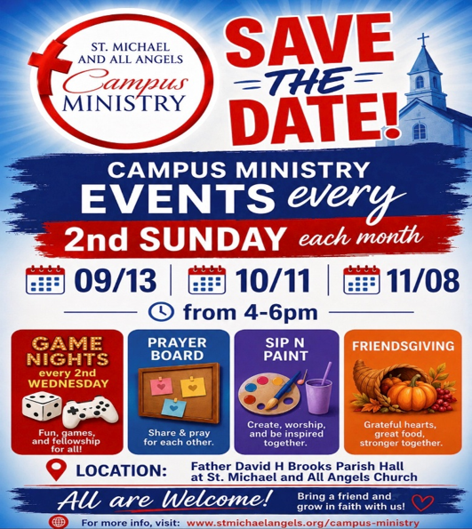

-6-
WELCOME TO ST. MICHAEL
We extend a warm welcome to our guests. Thank you for worshipping with us today. If you are without a church home, we invite you to join our church family. Please complete a Welcome Card, include your home address, phone number, and if you would like to receive our newsletter, news of special events and other happenings, please add your email address also.
About Us
Location: 1405 Melvin Street
Tallahassee, FL 32301
Phone: 850.681.0844
Office Hours: Monday to Friday
8:00 a.m. – 4:00 p.m.
Email:
office@stmichaelandallangels.org
Website:
www.stmichaelandallangels.org
Follow us on Instagram@smaa_tally
Find us on Facebook
OUR VISION is to be a cornerstone for serving the spiritual needs of the greater Tallahassee community, extending an eternal invitation to join our caring parish, and to enrich the spiritual life of all people as we journey with Christ.
OUR MISSION is to experience the Gospel of Jesus Christ by feeding the mind, body, and spirit of our community in fellowship and service.
Our Clergy and Administration
The Standing Committee
Diocese of Florida
Our Vestry & Staff
James Fort., Senior Warden
850.509.2419
Joseph Sams, III, Junior Warden
850.510.5717
Chioma Onyeozili, Vestry Clerk
Pamela Davis Greene
Alfred Lawson, Jr.
Marie Roberts
Alexis Roberts McMillan
Laureatte Scott, Treasurer
Dr. Kathleen Rodgers, Financial Secretary
Ivana Kenny Carmola and
Debralee LaSeur, Organists
Christopher White, Drummer/Choral Director
John Grayson, LEMs Coordinator
J. Byron Green, Outreach Coordinator
Elizabeth Humes, Administrative Assistant

