
St. Michael & All Angels Episcopal Church

Fourteenth Sunday after Pentecost
August 30, 2026, 10:00 a.m.

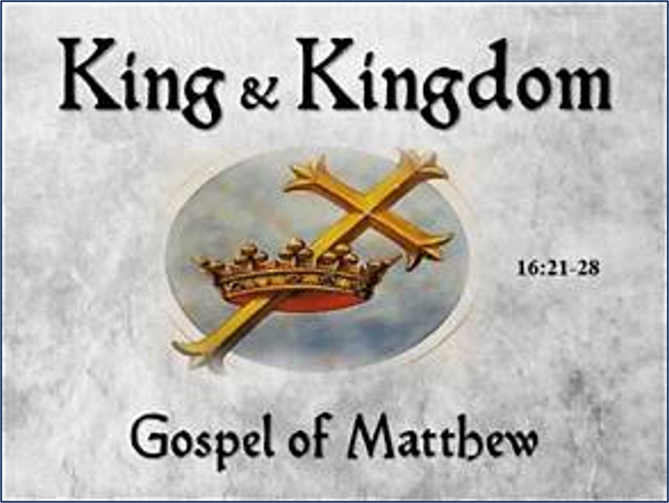

MORNING PRAYER– II
Officiant – Mrs. Alexis Roberts McMillan
Instrumental Prelude Mrs. Ivana Kenny Carmola
Opening Prayer
I was glad when they said unto me, “Let us go to the house of the Lord.”(Psalm 122:1)
Processional Hymn H372, Praise to the living God Leoni
Walk With Me
Confession of Sin BCP Pg. 79
Officiant Let us confess our sins against God and our neighbor.
All together, kneeling
Most merciful God, we confess our sins… The Invitatory and Psalter
All stand
Officiant Lord, open our lips. Pg. 80
People And our mouth shall proclaim your praise.
Glory to the Father and to the Son, and to the Holy Spirit: as it was in the beginning, is now, and will be for ever. Amen.
Officiant The mercy of the Lord in everlasting: Come let us adore him.
Venite Psalm 95:1-7 Pg. 82
Congregation is seated
The Psalm Psalm 105:1-6, 23-26, 45c Insert
Glory to the Father and to the Son, and to the Holy Spirit: as it was in the beginning, is now, and will be for ever. Amen.
The Lessons
First Reading Exodus 3:1-15 Insert
Second Reading Romans 12:9-21 Insert
Canticle 13 A Song of Praise Pg. 90
Sequence Hymn H675, Take up your cross, the Savior said Bourbon
The Homily Mr. James Fort

The Peace A498, Let There Be Peace on Earth Miller
Please be seated for the Offertory
Offertory Hymn A400, I have decided to follow Jesus Assam
Doxology (All Stand) A650, Praise God from Whom All Blessings Flow Hatton
Presentation of the Offering—Prayer to be said by Officiant
All things come of Thee, O Lord, and of Thine own have we given Thee.
The Apostles’ Creed Pg. 96
The Prayers
People stand or kneel
Officiant The Lord be with you. Pg. 97
People And also with you.
Officiant Let us pray.
The Lord’s Prayer
Suffrage A
The collect of the day Insert
A Collect for Guidance Pg. 100
A Prayer for Mission Pg. 100
the Prayers of The People Form 5 Pg. 389
The General Thanksgiving Pg. 101
Announcements
Recessional Hymn H539, O Zion, haste, thy mission high fulfilling Tidings
dismissal Pg. 102
Postlude

A= African American Heritage Hymnal (Ivory)
H= The Hymnal 1982 (blue)

PRAYER REQUESTS FOR PEACE, HEALING AND PROTECTION
For those at Home
Rosalyn Greene, Ella Woodbury, James Manning, Toni Jarmon, Rev. Leslie and Renee White, Rev. Ralph Griffith, Leonel Jones, Charles Walton, Joan Jackson Taylor, Christine Seymour, Kove Lawson, Cynthia Holland, Harriet Bowen, Livy Hitchcock, Sheila Gonzales, Kurt Blyden, Ashley Rodgers, Sandra Todman-Hart, Teresa Thomas, Elroy Todman, Christopher Marrow, Sean Gray, Debra Wynn, Fitzgerald Murraine and Anisah Sabur.
For those in the care of the Doctor
Dourest & Joann Robinson, John Melville, Lauren Sapp, Delores Brown, Hattie Olivia Scott, Jasmine Hartin, Rudolph & Melva Griffith, Pamelia Harris Williams, Kelcey Scott, Erica Scott, Eric Scott, Renrick & Veronica Alleyne, Jeffery Adams, Ena Mason, Darlene Sheppard, Devonia Sears, Landon Dyre, Brittany Lee, Herma Watson Taylor, Barbara Gruden, Carolyn Allen, Ann Dupree, Scott Allen, Ashley Griffith, Lee Scott, Leslie Warren, Will Baker, Ellie Potter, Lennie Helfand, Victor Laurie, Martha Laurie, Pamela Richards, Al Washington, Jesse Stewart, Catherine Davis, Zachery Smith, Julia Joyner, Anne Powell, Proctor Ford, Johnnie Flowers, Leonard Williams, Ethan Prichard, Annie DePutron, and Fr. I Ranfurly Brown of Nassau,
Joao Paulo Pinheiro de Miranda.
For those who care for the sick
Especially all doctors, nurses, scientists, and our own, Dr. Shaun Laurie, Dr. Nwamaka Onyeozili, Dr. Ross Howard McMillan, Dr. Ciara Robinson, Dr. Alaine Sharpe, Dr. Zollie White III , Zuri A. White, Cheston Williams, and Edwina Johnson.
For those in the Military
Linzie Bogan ll, Clark Bogan, Brianne Edwards, Vashti Thompson, Douglas Sampson, Jaelyn Guyton, Scott Haverstraw, Zavon Martin and Carina Richardson.
Suggested daily Readings for the Season of Pentecost: August 31 to September 5.
Mon. Job 12:1-6, 13-25 Psalm 25 John 8:21-32
Tue. Job 12:1; 13:3-17, 21-27 Psalm 26, 28 John 8:33-47
Wed. Job 12:1; 14:1-22 Psalm 38 John 8:47-59
Thurs. Job 16:16-22; 17:1, 13-16 Psalm 37:1-18 John 9:1-17
Fri. Job 19:1-7,-14-27 Psalm 31 John 9:18-41
Sat. Job 22:1-4, 21—23:7 Psalm 30, 32 John 10:1-18

SPECIAL PRAYERS
Birthday Prayer
Watch over thy children, O Lord, as their days increase; bless and guide them wherever they may be. Strengthen them when they stand; comfort them when discouraged or sorrowful; raise them up if they fall; and in their hearts may thy peace, which passeth understanding, abide all the days of their lives; through Jesus Christ our Lord. Amen.
Anniversary Prayer
God our Father, we pray that marriage may be held in honor, that couples may live together faithfully, according to their vows; and that members of every family may bear one another’s burdens and so fulfill the law of Christ; for his name’s sake. Amen.
Prayer for the Hurricane Season
Almighty and everlasting God, Lord of Heaven and Earth: Grant unto us thy suppliant people, protection against hurricanes, earthquakes, and other calamities; that in tranquility of weather we may rejoice in the comfort we desire and may always make right use of thy bountiful goodness through Jesus Christ our Lord. Amen.
Capital Campaign Prayer
Most gracious Lord Jesus Christ and generous source of all abundance, in gratitude we invite you to expand our hearts as we seek to increase and improve this place of worship, peace, healing, forgiveness, outreach, service and fellowship. May all who enter here be restored and strengthened on their journey of faith. Guide us Heavenly Father, that we may make manifest your vision of a beloved and enlightened church and community, and be a shining example of the living presence of the Holy Spirit. May we and our Capital Campaign be a channel of God’s abundant grace. Through Jesus Christ our Lord we pray. Amen.
HAPPY BIRTHDAY/ANNIVERSARY TO OUR CHURCH FAMILY!
JoAnn Robinson (8/31), Abigail Erefah (9/3), Christopher White (9/3), Sherika White (9/4),
Darren & Ivana Carmola (9/5).

Serving today, Sunday, August 30.
Crucifer: Mr. Charlie Clark Lectors: Dr. Neil James
Vestry: Ms. Chioma Onyeozili Ms. Chioma Onyeozili
Ms. Elizabeth Hooker
Altar Guild: Dr. Edith Onyeozili

Ushers & Greeters: AV: Ms. Leslie Warren

.
ANNOUNCEMENTS
St. Michael and All Angels Monthly Game Night
Join us on September 9th, from 6:00 p.m. – 9:00 p.m. for an evening of fellowship and fun. Light refreshments (potluck finger foods and drinks) will be provided. Come out and enjoy the time
together—bring a friend!
Pray especially for the following
Carlton Maddox—trying to put his life back together
John Melville—recovering at home
Ann Powell—in the care of the doctor
JoAnn Robinson—recovering at home
Eugene Wesley, III

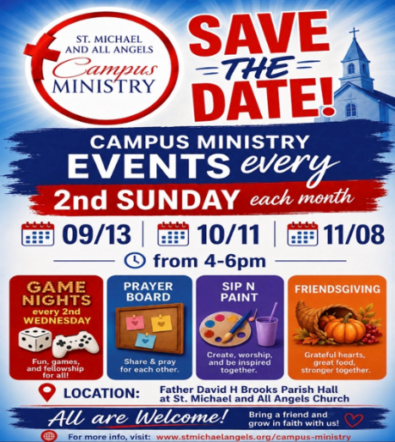

New–Priest Search Prayers

Prayer 3: For Our Church Leadership and Search Committee.
O Lord,
Guide those entrusted with this sacred search. Grant them discernment and clarity as they pray, interview, and consider candidates. May their decisions reflect Your will, and may our church continue to grow in faith and service.

.
DON’T STAY AWAY FROM CHURCH
Don’t stay away from church:
Because you are poor. There is no admission charge.
Because it rains. Most of us go to work in the rain.
Because it’s hot. It’s sometimes hot at your house too.
Because no one invited you. People go many other places without being asked.
Because you don’t like the pastor. He is human just as you are.
Because they are hypocrites at church. You associate with hypocrites every day. Because you need a little weekend vacation occasionally. No one can take a vacation from God.

WELCOME TO ST. MICHAEL
We extend a warm welcome to our guests. Thank you for worshipping with us today. If you are without a church home, we invite you to join our church family. Please sign the guest register, include your home address, phone number, and if you would like to receive our newsletter, news of special events and other happenings, please add your email address also.
About Us
Location: 1405 Melvin Street
Tallahassee, FL 32301
Phone: 850.681.0844
Office Hours: Monday to Friday
8:00 a.m. – 4:00 p.m.
Email:
office@stmichaelandallangels.org
Website:
www.stmichaelandallangels.org
Follow us on IG::smaa_tally
Find us on Facebook
OUR VISION is to be a cornerstone for serving the spiritual needs of the greater Tallahassee community, extending an eternal invitation to join our caring parish, and to enrich the spiritual life of all people as we journey with Christ.
OUR MISSION is to experience the Gospel of Jesus Christ by feeding the mind, body, and spirit of our community in fellowship and service.
Our Clergy
The Standing Committee
Diocese of Florida
Our Vestry & Staff
James Fort, Senior Warden
850.509.2419
Joseph Sams III, Junior Warden/Acolytes Coordinator
850.510.5717
Chioma Onyeozili, Vestry Clerk
Pamela Davis Greene
Alfred Lawson, Jr.
Marie Roberts
Alexis Roberts McMillan
Laurette Scott, Treasurer
Dr. Kathleen Rodgers, Financial Secretary
Ivana Kenny Carmola and
Debralee LaSeur, Organists
Christopher White, Drummer/Choral Director
John Grayson, LEMs Coordinator
J. Byron Green, Outreach Coordinator
Elizabeth Humes, Administrative Assistant

