Maundy Thursday APRIL 17, 2025
MASS OF THE LAST SUPPER
Instrumental Prelude Ubi Caritas
Processional Hymn H321, v1-2, My God, thy table now is spread Rockingham
THE WORD OF GOD
Celebrant Blessed be God: Father, Son, and Holy Spirit.
People And blessed be his kingdom, now and forever. Amen
The Collect of the day BCP pg. 274
Old Testament Lesson Exodus 12:1-14(a)
The Psalm Psalm 78:14-20, 23-25 BCP pg. 696
The Epistle 1 Corinthians 11: 23-26
Gradual Hymn H143,v1-3, The glory of these forty days Erhalt uns, Herr
The Holy Gospel John 13:1-17, 31b-35
Sequence Hymn H143, v4-5, The glory of these forty days Erhalt uns, Herr
Homily Rev. Hugh Chapman
The washing of the feet ceremony
The Prayers of the People Form V BCP pg. 389
The Peace May the Peace of the Lord Nolan
May the peace of the Lord bring: Joy, Love, Comfort, Hope, Rest, Life
May the peace of the Lord surround you. May the peace of the Lord go with you. Amen.
Offertory H171, Go to Dark Gethsemane Petta
Doxology H380, Praise God from whom all blessings flow Old 100th
Presentation Hymn H158, Ah, holy Jesus Herzliebster Jesu
The Great Thanksgiving Eucharistic Prayer A BCP pg. 361
Communion Hymn H325, Let Us Break Bread together Let Us Break Bread
Post-Communion Prayer BCP pg. 365
Procession to the altar of repose
Processional Hymn H324, Let all mortal flesh keep silence Picardy
Stripping of the Altar Psalm 22 (Deus, Deus meu) BCP pg. 610
The Solemn Watch follows. All Leave in Silence

Announcements
Upcoming Holy Week and Easter Services
Good Friday, April 18th, 12 Noon Midday Solemn Liturgy
Sermon, Prayers, and Communion from the Altar of Repose
Saturday, April 19th Day of Preparation
Sunday, April 20th Easter Day
High Mass and Indoor Procession
Maundy Thursday
This is the traditional English name for the Thursday preceding Easter, and it is derived from the first antiphon of the ceremony of the washing of the feet–Mandatum novum (John 13:34), There are two other traditional liturgical features–the Blessing of the Holy Oils and the Reconciliation of Penitents (no longer used anymore). In the Western Church since 1955, the Maundy Thursday Mass has been celebrated in the evening. White vestments are worm, and the altar is adorned in festive manner. Traditionally, the reserved sacrament was consumed by the priest and the host used for the Maundy Thursday service was taken to an Altar of Repose. At the celebration of the Eucharist, the bells are rungs at the Gloria in Excelsis and then remain silent until the Paschal Vigil (1st mass of Easter). To complete the rite for the day, a solemn watch begins immediately following the service which ends in silence.

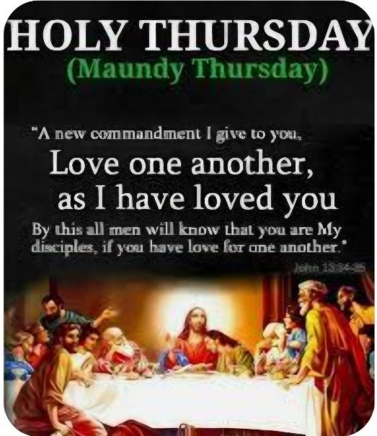

Welcome to st. Michael
We extend a warm welcome to our guests. Thank you for worshipping with us today. If you are without a church home, we invite you to join our church family. Please sign the guest register, include your home address and phone number, and if you would like to receive our newsletter, news of special events and other happenings, please add your email address also.
OUR VISION is to be a cornerstone for serving the spiritual needs of the greater Tallahassee community, extending an eternal invitation to join our caring parish, and to enrich the spiritual life of all people as we journey with Christ.
OUR MISSION is to experience the Gospel of Jesus Christ by feeding the mind, body, and spirit of our community in fellowship and service.
Our Clergy and Administration
The Standing Committee
Diocese of Florida
The Reverend Hugh Chapman, Rector
850.559.0481
Our Vestry and Staff
Mr. James Fort, Senior Warden
850.509.2419
Mr. Joseph Sams III, Junior Warden
850.510.5717
Chioma Onyeozili, Vestry Clerk
Pamela Davis Greene
Alfred Lawson, Jr.
Alexis Roberts McMillan
Marie Roberts
Laureatte Scott, Treasurer
Dr. Kathleen Rodgers, Financial Secretary
Ivana Kenny Carmola and
Debralee LaSeur-Helfand, Organists
Christopher White, Drummer/Choral Director
John Grayson, LEMs Coordinator
J. Byron Greene, Outreach Coordinator
Elizabeth Humes, Administrative Assistant

