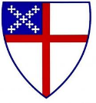
St. Michael & All Angels Episcopal Church

Twelfth Sunday after Pentecost
August 20, 2023, 10:00 a.m.

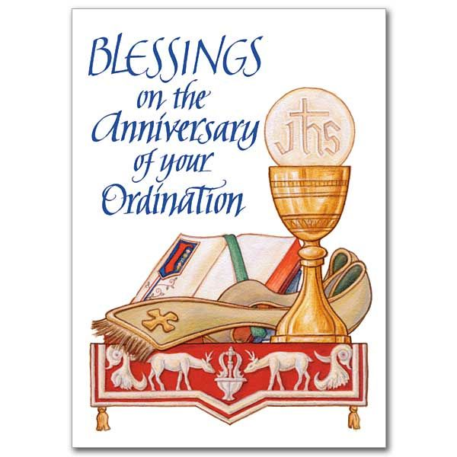

HOLY EUCHARIST – RITE TWO
Prelude L191, Hi Eye Is on the Sparrow Gabriel arr by Boyer
Solo: Ms. Eugenia Chapman
Opening Prayer
Almighty and eternal God, so draw our hearts to you, so guide our minds, so fill our imaginations, so control our wills, that we may be wholly yours, utterly dedicated to you; and then use us we pray as you wish, and always to your glory and the welfare of your people; through our Lord and Savior Jesus Christ. Amen.
Processional Hymn H643, My God How Wonderful thou Art
THE WORD OF GOD
Opening Acclamation BCP pg. 355
Gloria pg. 356
Collect of the Day Insert
The Lessons [Congregation is seated]
Isaiah 6:1-8
Psalm 8
Glory be to the Father, and to the Son, and to the Holy Spirit,
As it was in the beginning, is now, and ever shall be, world without end. Amen.
1 Thessalonians 5:12-24
Gradual Hymn L111, v 1-2, Come, Thou Fount of Every Blessing Nettleton
The Holy Gospel John 15:9-17 Deacon Joseph Bakker
Sequence Hymn L111, v 3, Come, Thou Fount of Every Blessing Nettleton
The Sermon Dr. Geraldine Smith Baker
The Nicene Creed pg. 358
The Prayers of the People Form 11 pg. 385
Confession of Sin & Absolution pg. 360
The Peace L188, It Is Well with My Soul Bliss Liturgical Dance by Ms. Pennela Chapman

-1-

Offertory Hymn H655, O Jesus I Have Promised Nyland
Doxology & Procession A651, Praise God From Whom All Blessings Flow Old 100th
Presentation of the Offering – prayer to be said
Father, we offer you these gifts which you have given us: this bread, this wine, this money. With them we offer ourselves, our lives, and our work, to become through your Holy Spirit, a reasonable, holy and lively sacrifice. As this bread and wine become the Body and Blood of Christ, so may we and all your people become channels of your love; through the same Christ our Lord. Amen.
organ interlude

The Great Thanksgiving
Eucharistic Prayer A BCP pg. 361-366
Sanctus pg. 362
The Lord’s Prayer pg. 364
The Breaking of the Bread
Agnus Dei
The Invitation
Holy Communion
Communion Hymn 1 H335, I Am the Bread of Life Tollan
Communion hymn 2 L232, Thank You, Lord Spiritual
special selection I Want Jesus to Walk With Me
Solo: Mr. Christopher White
Post Communion Prayer pg. 365
Benediction
Announcements
Recessional Hymn H423, Immortal, Impossible St. Denio
Dismissal
A=African American Hymnal (ivory) H= 1982 Hymnal (blue) L= Lift Every Voice & Sing (Red)

-2-

PRAYER REQUESTS FOR PEACE AND HEALING
For those at Home
Fr. Laughton Thomas, Rosalyn Greene, Ella Woodbury, James Manning, Toni Jarmon, Rev. Leslie and Renee White, Rev. Ralph Griffith, Leonel Jones, Charles Walton, Joan Jackson Taylor, Christine Seymour, Mary Ann Nottage, Kove Lawson, Cynthia Holland, Genevie Vaughn, Harriet Bowen, Livy Hitchcock, Sheila Gonzales, and Fr. Terrance Rosheuvel.

For those in the care of the Doctor
Dourest & Joann Robinson, John Melville, Lauren Sapp, Dr. Derek Spencer, Delores Brown, Hattie Olivia Scott, Alexis Shermise Brown, Jasmine Hartin, Shevette Newkirk, Rudolph & Melva Griffith, Delois Abraham, Stella Harris, Pamelia Harris Williams, Klcey Scott, Erica Scott, Renrick & Veronica Alleyne, Jeffery Adams, Mayleen Rosheuvel, Ena Mason, Darlene Sheppard, Devonia Sears, Landon Dyre, Brittany Lee, Herma Watson Taylor, Barbara Gruden, Carolyn Allen, Carl Maxwell, Ann Dupree, Bill Bush, Luann Hickman, Harold Dickey, Sterling Rinks, Scott Allen, Ashley Griffith, Oscar Felker, Fritz Roy, Mark Thomas, Daniella Greenway Thomas, Terrence Harris, Barbara Stovell, Lynn Kimmel, Will Baker, David Thomas Wiley, Barbara Lynn, Lee Scott, Leslie Warren, Spencer Stapleton, Ellie Potter, Randy Frazier, Lennie Helfand and Fabienne Bailey Brown.

For those who care for the sick
Especially all doctors, nurses, scientists, and our own, Dr. Shaun Laurie, Dr. Nwamaka Onyeozili, Dr. Ross Howard McMillan, Dr. Ciara Robinson, Dr. Alaine Sharpe, Dr. Edwin Thorpe, Zuri A. White and Cheston Williams.

For those in the Military
Linzie Bogan ll, Clark Bogan, Brianne Edwards, Vashti Thompson, Thandi Williams and Douglas Sampson.
SPECIAL OCCASION PRAYERS
Birthday Prayer
Watch over thy children, O Lord, as their days increase; bless and guide them wherever they may be. Strengthen them when they stand; comfort them when discouraged or sorrowful; raise them up if they fall; and in their hearts may thy peace, which passeth understanding, abide all the days of their lives; through Jesus Christ our Lord. Amen.

Anniversary Prayer
God our Father, who made men and women to live together in families: we pray that marriage may be held in honor; that couples may live together faithfully, according to their vows; and that members of every family may grow in mutual love and understanding, in courtesy and kindness, so that they may bear one another’s burdens and so fulfill the law of Christ; for His name’s sake. Amen.
-3-

SPECIAL PRAYERS
Capital Campaign Prayer
Most gracious Lord Jesus Christ and generous source of all abundance, in gratitude we invite you to expand our hearts as we seek to increase and improve this place of worship, peace, healing, forgiveness, outreach, service and fellowship. May all who enter here be restored and strengthened on their journey of faith. Guide us Heavenly Father, that we may make manifest your vision of a beloved and enlightened church and community, and be a shining example of the living presence of the Holy Spirit. May we and our Capital Campaign be a channel of God’s abundant grace. Through Jesus Christ our Lord we pray. Amen.
Prayer for the Hurricane Season
Almighty and everlasting God, Lord of Heaven and Earth: Grant unto us thy suppliant people, protection against hurricanes, earthquakes, and other calamities; that in tranquility of weather we may rejoice in the comfort we desire and may always make right use of thy bountiful goodness through Jesus Christ our Lord. Amen.
HAPPY BIRTHDAY/ANNIVERSARY TO OUR CHURCH FAMILY!
Loretta Anwuri (8/20), Linda Billups (8/21), Lauren Sapp (8/22), Tangy Williams (8/23), Altha Manning (8/23), Shauna Allen (8/24), Sam Oliver ll (8/26), Al & Delores Lawson (8/22), Akachi & Loretta Anwuri (8/25).
Serving today, Sunday, August 20
Serving today, Sunday, August 20
Acolytes: Mr. James Fort LEMS: Mr. John Grayson
Mr. Joseph Sams Mrs. Alexis McMillan
Gospel Book Bearer: Mr. Collin Laurie Lectors: Dr. Simone Hruda
Crucifer: Mr. Prokop Hruda Dr. Marcy Muldrow Sanders
MC: Mr. Porteh Sayon Dr. Neil James
Vestry: Ms. Kimberly Douglas Organist: Mrs. Debralee LaSeur-Helfand
Altar Guild: Mrs. Dawn Freeman AV: Mr. Sean Warren-Bailey
Suggested daily Readings for the Season of Pentecost: August 21–August 26
Mon. Judges 17:1-13 Psalm 106:1-18 John 5:19-29
Tue. Judges 18:1-15 Psalm [120], 121 John 5:30-47
Wed. Judges 18:16-31 Psalm 119:145-176 John 6:1-15
Thurs. Job 1:1-22 Psalm 131, 132 John 6:16-27
Fri. Job 2:1-13 Psalm 140, 142 John 6:27-40
Sat. Job 3:1-26 Psalm 137:1-6(7-9) John 6:41-51

-4-

ANNOUNCEMENTS

44 years and counting
I thank God today for affording me the privilege of serving as one of His priests for the last 44 years—it has been quite a journey. Let me pay tribute to Genevieve and our girls, who have mostly been on this journey of faith with me across four dioceses! Today I recommit myself to the service of Almighty God and ask your prayers, as I seek to faithfully serve here at St. Michael & All Angels. Fr. Hugh+
Al & Delores Lawson to Celebrate
On Sunday August 27th, Congressman Al Lawson and his wife Delores will celebrate 53 years of married life! In the absence of the rector, Fr. Jim May has been invited to celebrate and preach that day. A reception will follow the celebration of the Eucharist.
House Meeting Launch
September will be observed as Justice Month here at SMAA with Lead Organizer Leah Wiley visiting with us and sharing the pulpit with the rector on Sunday September 17th. September 21st is the official launch date and the topics to be discussed include:-
(i) Affordable Housing,
(ii) Youth Arrest
(iii) Gun Violence Interruption
Attendees are being asked to wear 70’s Attire, and food and music will be provided.
Campus Ministry Kick Off
Our campus ministry begins on Sunday August 27th in the Fellowship Hall (4:00-6:00 pm). There will be food, music and fun. The theme is “Building Safe Relationships”, and the speaker is Mr. Byron Greene. Help spread the word.
Invited to Serve
Fr. Charlie Holt who was unsuccessful in his bid to become the next Bishop of the Diocese of Florida, has accepted an appointment to serve as the next rector of St. Mark’s Episcopal Church in Jacksonville. We wish him all the best.
Church Pictorial Directory
Parish family, we have an opportunity to bring parishioners back together through a custom church pictorial directory. For this to be a success, all members need to be involved. We need fifty families to sign up. Those parishioners who are out of town can submit a photograph and the cost will be $15.00 per family. For those of us here in Tally, photographs will be taken here at the church on October 31st between the hours of 2:00 pm and 8:30 pm.

-5-

From the Rector’s Desk
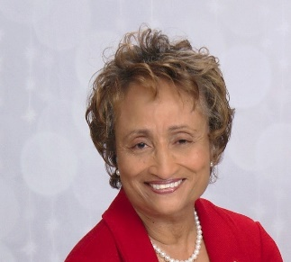
Meet the Speaker
Geraldine Williams Smith (Baker) is a life-long resident of the Jacksonville area, where she attended and graduated from local schools. She received her Bachelor of Arts degree in English from Florida A & M University and her Master of Arts in English from the University of Mississippi. She also received her Doctorate of Education degree in Educational Leadership from the University of North Florida. Recently, she completed certification in The Episcopal Church’s Education for Ministry Program (EfM).
Dr. Smith’s passion in life is teaching as evidenced throughout her adult life beginning with her teaching at Crispus Attucks Grammar School in Chicago, Illinois. She would then teach as a graduate student at the University of Mississippi and later at Marks Junior High School in Marks, MS. After returning to Jacksonville, Dr. Smith taught for 18 months at then Forrest High School before joining the faculty at Florida Junior College where she taught English and Literature for 22 years while serving for 15 years as Department Chair of Communications and Humanity. There she was the co-founder of the FAME (Format for Affecting Minority Enrollment) program and lead research teacher for Jacksonville’s Black History Calendar. She retired from St John’s River State College as the Dean of Adult Studies, Student Success, and Testing. Since her formal retirement, she has taught at the University of Phoenix and served as its Communications and Humanities Chair and at Stratford University in Baltimore, Maryland. She currently teaches on an as needed basis at Florida State College at Jacksonville. She also facilitates workshops at the University of North Florida’s Olli Program on The Harlem Renaissance.
In 1976, Dr. Smith became a communicant of St. Philip’s Episcopal Church in Jacksonville, where she served as a Eucharistic Minister and adult Sunday School teacher. She is married to LTC (Ret.) Wilson Baker, Jr. and is the proud mother of Karen Estella Smith. She keeps busy with membership in the Jacksonville Chapter of The Links, Incorporated and Alpha Kappa Alpha International Sorority, Incorporated.

-6-

WELCOME TO ST. MICHAEL
We extend a warm welcome to our guests. Thank you for worshipping with us today. If you are without a church home, we invite you to join our church family. Please sign the guest register, include your home address, phone number, and if you would like to receive our newsletter, news of special events and other happenings, please add your email address also.
About Us
Location: 1405 Melvin Street
Tallahassee, FL 32301
Phone: 850.681.0844
Office Hours: Monday to Friday
8:00 a.m. – 4:00 p.m.
Email:
office@stmichaelandallangels.org
Website:
www.stmichaelandallangels.org
Follow us on Twitter @SMAA_Tally
Find us on Facebook
OUR VISION is to be a cornerstone for serving the spiritual needs of the greater Tallahassee community, extending an eternal invitation to join our caring parish, and to enrich the spiritual life of all people as we journey with Christ.
OUR MISSION is to experience the Gospel of Jesus Christ by feeding the mind, body, and spirit of our community in fellowship and service.
Our Clergy
The Right Reverend John Howard
Bishop – Diocese of Florida
The Reverend Hugh Chapman
Rector
340.513.1123
Frhugh_chappy63@yahoo.com

Our Vestry & Staff
Dr. Shaun Laurie, M.D., Senior Warden
850.570.5789
Charlie Clark, Junior Warden
850.631.0780
Linda Billups
Kimberly Douglas
Margaret Edwards, Vestry Clerk
Laureatte Scott, Treasurer
Dr. Kathleen Rodgers, Financial Secretary
Ivana Kenny Carmola and
Debralee LaSeur-Helfand, Organists
Chris White, Drummer/Choral Director
John Grayson, LEMs Coordinator
J. Byron Green, Outreach Coordinator
Elizabeth Humes, Administrative Assistant

